EMBARGOED PRESS RELEASE
NEWS IS NOT FOR PUBLICATION UNTIL MAY 18, 2023 AT 10:00 AM EDT / 7:00 AM PDT | 14:00 UTC/GMT | 15:00 BST | 16:00 CEST | 17:00 MSK

MCINTOSH LAUNCHES NEW ML1 MKII LOUDSPEAKER

The Reinvented Loudspeaker Pays Homage to The Brand’s Speaker Origins with New-Age Improvements

BINGHAMTON, NY (MAY 18, 2023) – McIntosh, the premier designer and manufacturer of high-fidelity audio equipment, is excited to announce the launch of its latest speaker – ML1 MKII Loudspeaker, a new and improved version of the brand’s original 1970s ML1.

The ML1 MKII is a unique loudspeaker where vintage style meets contemporary sound. Reborn with a similar bass response as the initial iteration but without the need of an equalizer, the ML1 MKII can be connected with amplifiers up to 600 Watts to fill the largest of rooms with life-size sound. It also features wide dispersion, which allows for an equal distribution of sound throughout the listening area, unlike any other loudspeaker.

The external design of the ML1 MKII retains the same charm as the original ML1 with its oiled American Walnut solid wood cabinets and satin finish veneers. Whereas, internally, it features a full modern revamp to reflect McIntosh’s present-day high performance speaker technology. The ML1 MKII is a 4-way speaker that uses five separate speaker drivers to produce a uniform listening area and astonishing sound quality.
- Woofer: one 12" woofer in a sealed enclosure with a polypropylene cone and dust cap with synthetic rubber suspension.
- Lower Midrange: two 4" lower midrange drivers in a sealed sub-enclosure also with polypropylene cones and dust caps with synthetic rubber suspension.
- Upper Midrange: one 2" soft dome upper midrange.
- Tweeter: one 3/4" Titanium dome tweeter (the same tweeter used in our XR50 and XR100 speakers).
“While we have been making loudspeakers for over five decades, the ML1 will always be our first and holds a special place in our hearts here at McIntosh,” said McIntosh President Charlie Randall. “We’re incredibly excited to showcase how far the brand has come over the more than half a century with the renewed ML1 and hope our community of listeners will enjoy listening to their favorite sounds on this classic remodel.”

The ML1 MKII additionally includes a matching stand with a vintage die cast aluminum name badge on the base. The stand is designed to elevate and position the ML1 loudspeaker for optimum imaging and listening enjoyment. It comes with feet for use on hard floors, and spikes for use on carpet. The reimagined loudspeaker can also be set directly on the floor or placed on a sturdy piece of furniture.
AVAILABILITY
The ML1 MKII will be available through Authorized McIntosh Dealers for a targeted MSRP of $6,000 per speaker ($12,000 per pair) starting in July 2023.

LINK TO HI RES IMAGES: HERE

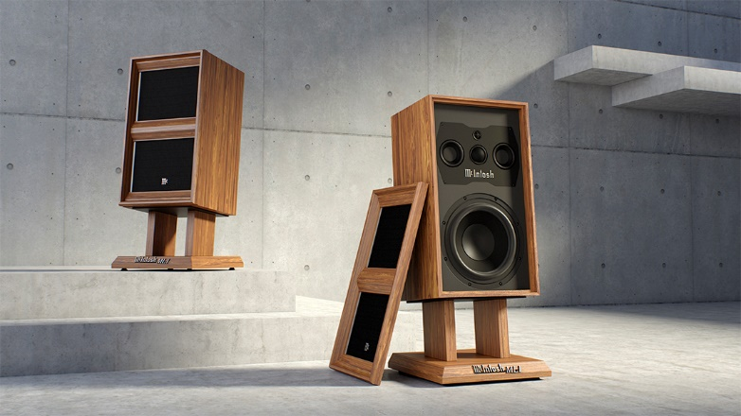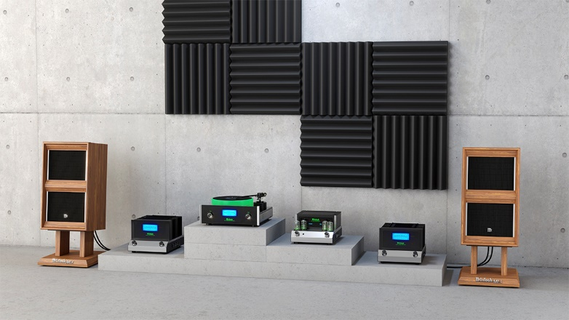

ABOUT MCINTOSH
McIntosh Laboratory, Inc. is the premier American designer and manufacturer of high-fidelity audio equipment. Founded in 1949, McIntosh products are handcrafted by experts passionate about creating an unmatched sonic experience. From its factory in Binghamton, New York to all corners of the world, the McIntosh blue meters have become a symbol of quality audio and continue to own the premiere position in home audio entertainment for discerning listeners. Powering events like President Lyndon Johnson’s inauguration speech, world-renowned concert systems like Woodstock, the Grateful Dead’s Wall of Sound and Despacio, McIntosh has shaped some of the most important moments in music and culture. McIntosh gives music enthusiasts the power to create their ultimate sound experience. Visit www.mcintoshlabs.com to learn more.

